1.

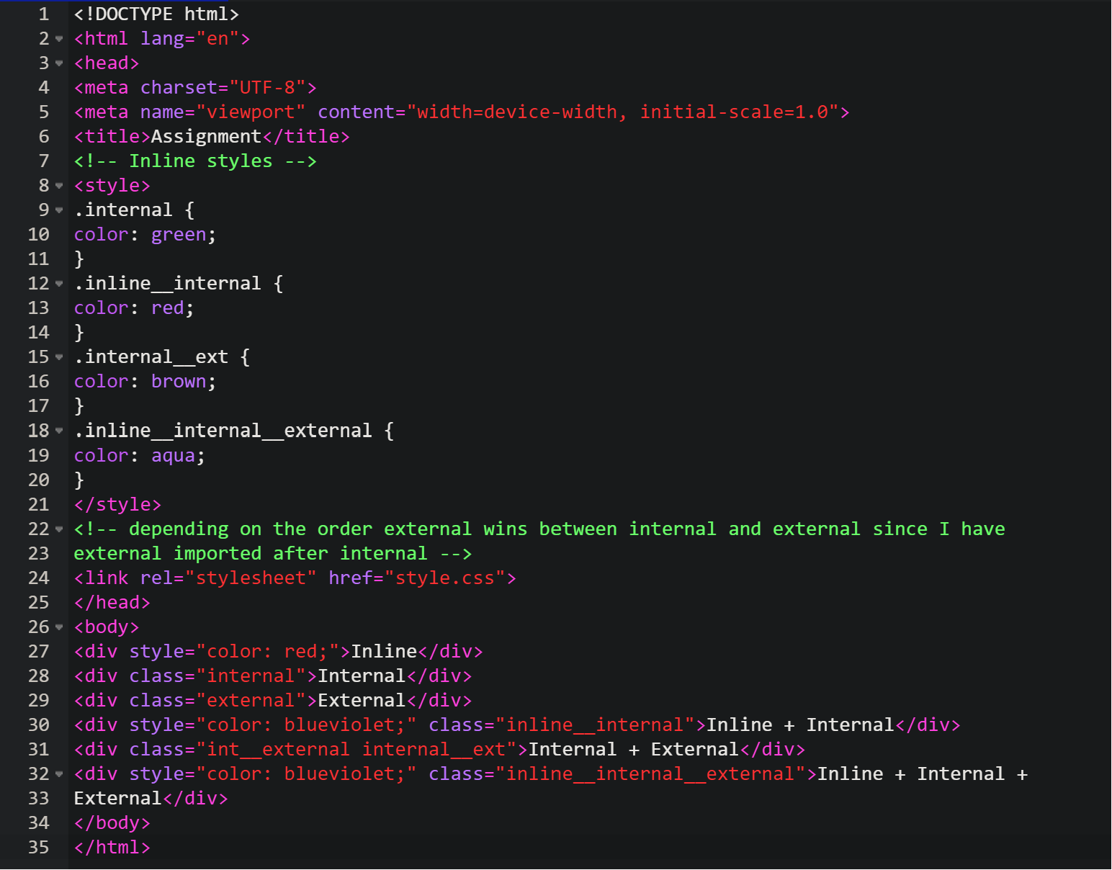

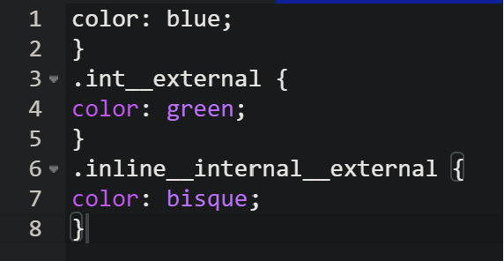

OUTPUT:

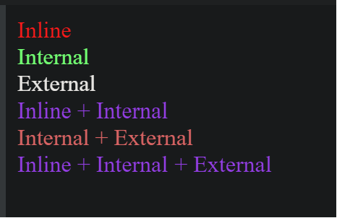

2.

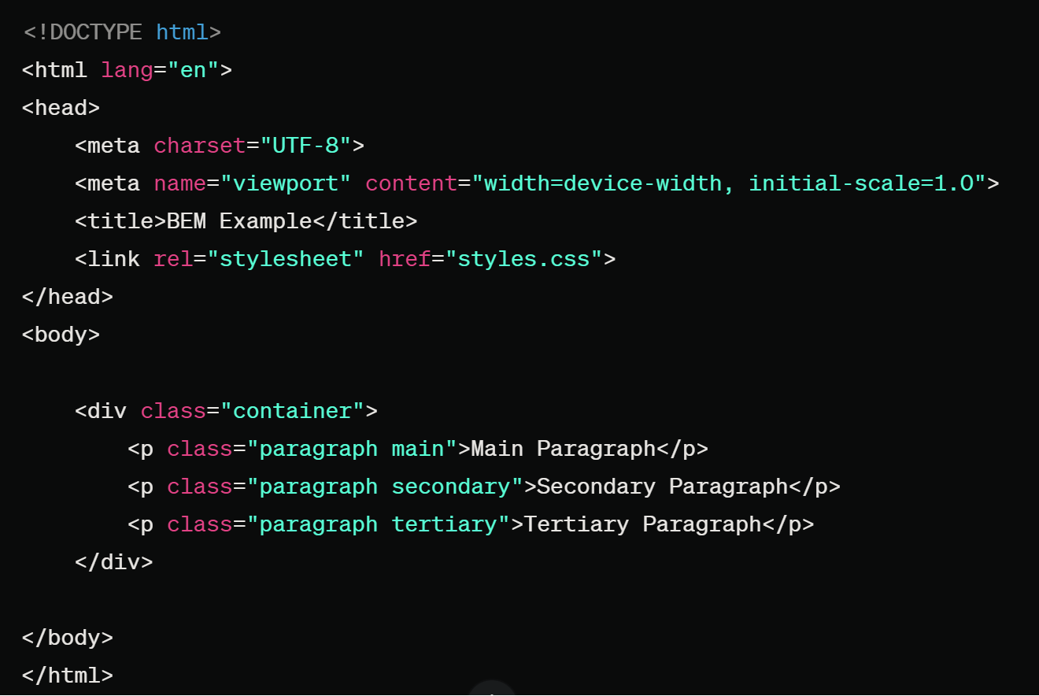

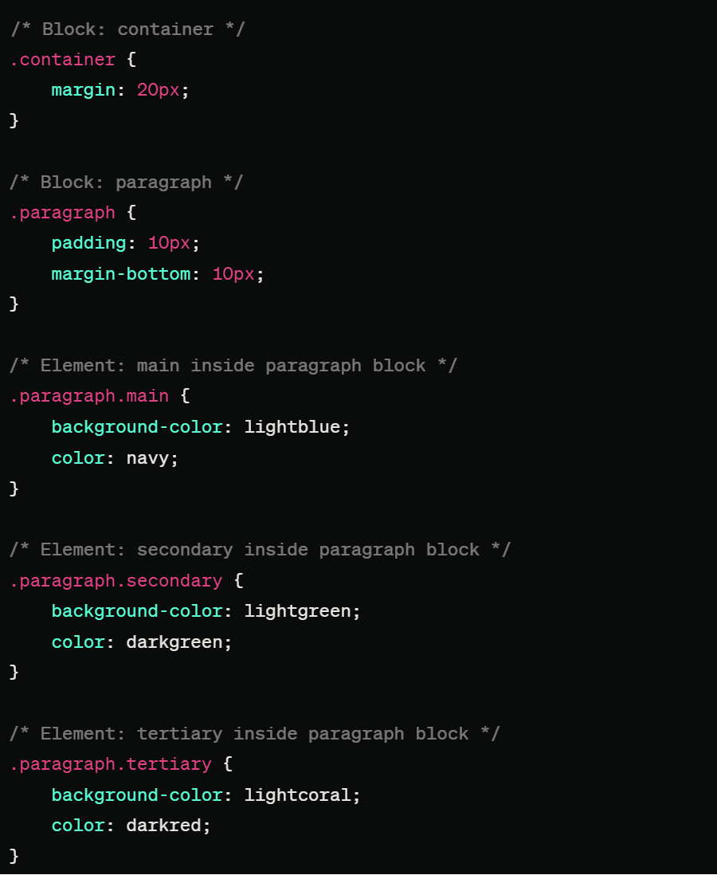

OUTPUT:

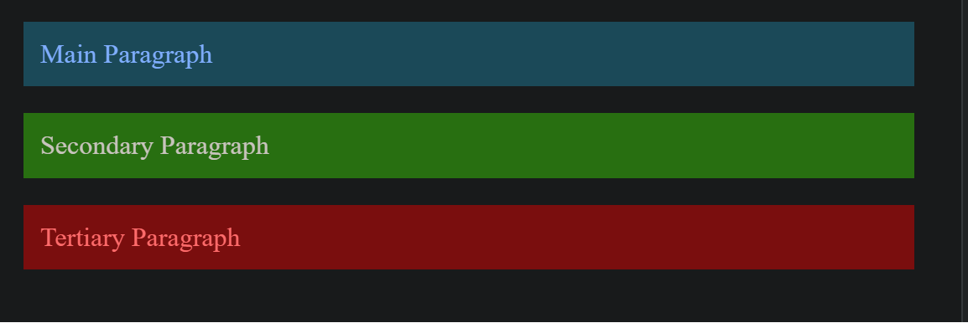

3.

<!DOCTYPE html>

<html lang="en">

<head>

<meta charset="UTF-8">

<meta name="viewport" content="width=device-width, initial-scale=1.0">

<title>Styled Form</title>

<link rel="stylesheet" href="styles.css">

</head>

<body>

<div class="form-container">

<h2>Contact Us</h2>

<form action="#" method="post">

<!-- Name input -->

<label for="name">Name:</label>

<input type="text" id="name" name="name" placeholder="Your name" required>

<!-- Email input -->

<label for="email">Email:</label>

<input type="email" id="email" name="email" placeholder="Your email" required>

<!-- Message textarea -->

<label for="message">Message:</label>

<textarea id="message" name="message" placeholder="Write your message" rows="4" required></textarea>

<!-- Submit button -->

<button type="submit">Submit</button>

</form>

</div>

</body>

</html>

/\* Body styles \*/

body {

font-family: 'Arial', sans-serif;

margin: 0;

padding: 0;

display: flex;

justify-content: center;

align-items: center;

min-height: 100vh;

background-color: #f4f4f4;

}

/\* Form container styles \*/

.form-container {

background-color: #fff;

border-radius: 8px;

box-shadow: 0 0 10px rgba(0, 0, 0, 0.1);

padding: 20px;

width: 300px;

opacity: 0.9; /\* Applying opacity to the entire form container \*/

}

/\* Heading styles \*/

h2 {

text-align: center;

color: #333;

}

/\* Label styles \*/

label {

display: block;

margin-top: 10px;

color: #555;

}

/\* Input and textarea styles \*/

input,

textarea {

width: 100%;

padding: 8px;

margin-top: 4px;

margin-bottom: 10px;

border: 1px solid #ccc;

border-radius: 4px;

box-sizing: border-box;

}

/\* Button styles \*/

button {

background-color: #4285f4;

color: #fff;

padding: 10px;

border: none;

border-radius: 4px;

cursor: pointer;

}

/\* Button hover effect \*/

button:hover {

background-color: #3367d6;

}

